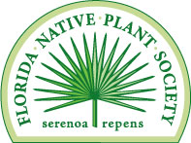

Announcement:

FNPS 2021 Cornelia McNamara Grant
The Florida Native Plant Society has established a Cornelia McNamara Grant program for the purpose of funding applied research on native plants and habitats, particularly those that are rare or imperiled. These are small grants ($1500 or less), awarded for a 1-year period, and intended to support research that will yield data to inform the management for or restoration of native species and habitats.

Application guidelines and details are on the FNPS Web site (www.fnps.org), click on ‘What We Do/Awards and Grants’. Questions regarding the grant programs should be sent to info@fnps.org.

Application deadline for the 2021 Awards is March 5, 2021. Awards will be announced at the May 2021 Annual Conference. Awardees do not have to be present at the Conference to receive award.

